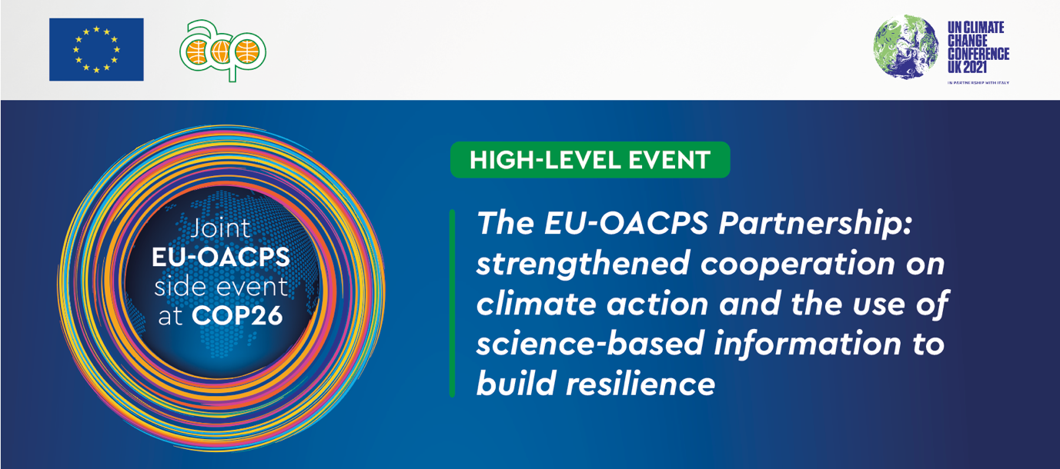

**BIOGRAPHY OF SPEAKERS AND PANELISTS**

**1. KEYNOTE SPEAKERS**

 **Director General DG INTPA, Mr Koen Doens**

**Mr Koen Doens** has held the position of Director-General for International Partnerships since October 2019 and has held other senior level positions in DG INTPA – then DG DEVCO including DDG from March 2018. He joined the Commission in 2004 and was Head of Cabinet of Louis Michel, Commissioner in charge of Development and Humanitarian Aid from 2004-2010 and was Head of the Commission Spokespersons’ Service from 2010-2014. He is a classical philologist by training and was a professor of Latin and Greek before becoming a Belgian diplomat serving in Syria, Iran and Russia. He has also served in several Belgian ministerial cabinets.   
   
**Secretary-General of the Organisation of African, Caribbean and Pacific States, H.E Mr Georges Rebelo Pinto Chikoti**

**H.E Mr Georges Rebelo Pinto Chikoti** has been appointed as Secretary General of OACPS in March 2020. Has devoted almost 30 years of his professional career to diplomacy and international relations, in a particularly complex and difficult global environment. This long experience allowed him to enhance his negotiation and dialogue skills. Prior of his appointment, he was Ambassador Extraordinary and Plenipotentiary of the Republic of Angola to the Kingdom of Belgium, the Grand Duchy of Luxembourg, and Head of Mission to the European Union.

**State Secretary Slovenian Presidency, Dr. Stanislav Raščan  
State Secretary Dr Stanislav Raščan** holds masters and doctorate degrees in political science. A career diplomat, he has been employed at the Ministry of Foreign Affairs since 1994. Dr Raščan is Assistant Professor of international security policy at the Faculty of Government and European Studies of the New University in Kranj.



**Ambassador of the Republic of Congo, H.E. Mr Léon Raphaël MOKOKO  
H.E. Mr Léon Raphaël MOKOKO**, Ambassador of the Republic of Congo in Brussels has more than 34 years of experience in private and public services and is the current Chair of the Subcommittee on Sustainable Development at the Organisation of African, Caribbean and Pacific States (OACPS).

**2. MODERATOR**

**Assistant Secretary General, Ms Cristelle Pratt**

**Cristelle Pratt** has thirty years of policy and practice experience at national, regional and international levels in both public and private sectors. While a large part of her career has been dedicated to serving members States of the Pacific region, she now serves 79 members and regions of the OACPS on priority issues for the environment and climate action, which she is passionate about.

**3. PANELISTS**

** Minister of Environment and Sustainable Development, Ivory Coast, H.E. Mr Jean-Luc Assi,**

**H.E. Mr Jean-Luc Assi** has post graduate degrees and diplomas from the University of Abidjan and the University of Paris 1 Sorbonne; respectively. Between 1993 and April 2021 Minister Assi has held various public and private sector positions. His most recent appointment before becoming Minister of the Environment and Sustainable Development in April 2021 was as the Deputy Managing Director of the National Drinking Water Office (ONEP) from January 2014 to December 2019.

**Hon. Kavydass Ramano, Ministry of Environment, Mauritius**

Mauritian notary and politician**, Hon. Kavydass Ramano** has been Chairman of Mauritius’ Freeport Authority from 2002 to 2004, Mayor of Quatre Bornes from 2003 to 2004 and Member of National Assembly from May 2010. He has been a member of the constituency of Belle Rose and Quatre Bornes since 2010 and Member of Parliament from December 2014 to October 2019. In November 2019 he was appointed Minister of the Environment, Solid Waste Management and Climate Change.



 **Minister of Environment , Haïti**, **S.E. Mr James Cadet,**

**H.E James Cadet** started his environmental career as assistant Head of service in the Directorate of Environmental Inspection and Monitoring within the Ministry of the Environment in 2013 and quickly rose to through the ranks to become Director of Environmental Inspection and Monitoring in 2015, also assumed charge of Legal Affairs at the Technical Secretariat of the General Directorate in 2016 and then held the position of Director of Climate Change in 2017. He became Minister of the Environment in July 2021.

**Mrs Myriam Ferran, Deputy Director General DG INTPA**

Since 2001, **Myriam Ferran** has worked for the European Commission in various capacities: in the Directorates-General for Enlargement, for Transport and Energy, for Neighbourhood and Enlargement Negotiations, for International Partnerships - as well as in the Cabinet of the European Enlargement Commissioner Olli Rehn. She has worked at Head of Unit and Director level and was recently appointed to the position of Deputy Director-General in DG INTPA in charge of three geographical Directorates. Prior to joining the Commission Ms Ferran served in the French government.

**Chief Executive Committee Member (CECM)- Minister - for Environment and Climate change, Isiolo County, Kenya, Ms Josphine Kirion Eregae**

**Ms Josephine Kirion-Eregae** is a Chief Executive Committee Member (CECM) for Environment and Climate change for Isiolo County Government. She has tertiary qualifications in Leadership and Governance, and amongst various achievements has: developed the Isiolo Water and Sanitation Act and Regulations; and, enacted the Isiolo Youth, women and People Living with Disability Enterprise Fund Act and Regulations; the Isiolo county Gender Policy; and the draft Child Protection Act. She has also operationalized the Early Childhood Development Act.

**Youth Leader, Mr Ernest Gibson**

**Mr Ernest Gibson** is a communications and development professional. He currently sits on the   
7-member United Nations Secretary General's Youth Advisory Group on Climate Change as the only Pacific Island representative. Ernest has worked in climate change projects across the Pacific, supporting community-led approaches to Climate Diplomacy and climate policy development.