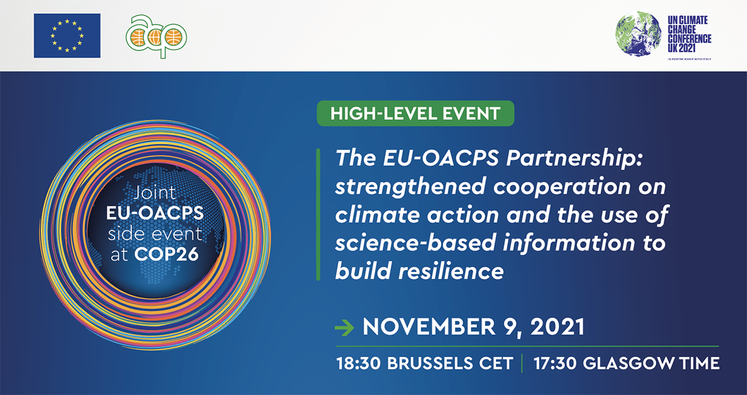

CONCEPT NOTE

Context
The 2021 UN climate change conference (COP26) is scheduled to take place from 1 to 12 November 2021 in Glasgow, under the presidency of the UK. The European Union, like in previous years, will provide a space (physical and digital) for side events seeking to stimulate the debate on key thematic areas, with the objective to facilitate dialogue with Party delegates and other participants, as well as to launch new initiatives and partnerships and to highlight inspiring and successful projects or policies.
In addition to the in-situ facilities, a COP26 studio will be set-up in Brussels as a virtual bridge between the EU institutions and the stakeholders and interest groups stationed in Brussels and the COP venue, respectively.
Background
Fighting climate change is one of the highest priorities in the political agenda of both the EU and of the 79 member countries of the Organisation of African, Caribbean and Pacific States (OACPS). Most EU and OACPS countries are currently facing multiple environmental challenges at various level, leading to serious impact for their countries’ welfare and development. Recent natural disasters taking place globally, such as droughts, desertification, hurricanes, and floods, have shown that the impacts of climate change do not stop at borders.
The EU-OACPS are longstanding partners in several fields and their cooperation on climate change has especially proven their capacity to deliver tangible results. An excellent example of this successful cooperation is The High Ambition Coalition, established in the context of the UNFCCC negotiation. Originated from the ACP-EU partnership, the alliance played an important role in the conclusion of the Paris Agreement in 2015. Eventually, in 2018, the EU and the OACPS released a joint declaration on climate change, in which they declared their joint commitment towards the attainment of the long-term goals of the Paris Agreement. In preparation for COP 26, the Communique of the ACP-EU Joint Parliamentary Assembly on climate action for COP 26 was adopted on 25 October 2021.

Objectives
This year the EU and the OACPS concluded de facto their negotiations on a new Partnership Agreement (known as “post-Cotonou), strengthening commitments on climate action and multilateral cooperation.
The Green Deal is the EU leading framework to fight climate change through ambitious policies at home and close cooperation with international partners. At the same time, the 112th OACPS Council of Ministers, adopted the Resolution on Climate Action towards COP26 which reiterated the urgency of taking action to address climate change.
The joint side event will take place on November 9th, 2021 at 5.30pm (Glasgow time).
The high-level panel aims at:

- Highlight and provide examples that showcase the strength of the EU and the OACPS cooperation in the context of climate action.
- Recall the importance of strong joint action to address climate adaptation in OACPS countries, the most vulnerable countries to the impacts of climate change.
- Inform and give maximus visibility to EU-OACPS climate action programmes.
- Engage with key stakeholders in the field of climate change active in the EU and in the OACPS.
- Generate press coverage including a press release.

Organization and participants

The side event will take place virtually and will be co-organized by the Directorate General for International Partnerships (DG INTPA) and the Secretariat of the OACPS.

The event will be moderated by the OACPS Assistant Secretary General (ASG) for the Environment and Climate Action (ECA) Department, Assistant Secretary General, Ms Cristelle Pratt. The Director General of the European Commission’s DG International Partnerships (INTPA) and the OACPS Secretary General will deliver opening remarks. A representative of the Slovenian Presidency of the Council of the EU will provide welcoming remarks. The Ambassador of Congo (Brazzaville) and Chair of the OACPS Subcommittee on Sustainable Development will deliver introductory remarks. A panel composed of OACPS Ministries and High-level EU officials from DG INTPA will present concrete examples of support by the Intra-ACP GCCA+ and ClimSA programmes and the added value of the OACPS-EU partnership. A youth Pacific leader will also participate to the event providing first hand experiences and insights from the most vulnerable countries to climate change.

Representatives from the Negotiation Groups of the United Nations Framework Convention on Climate Change (UNFCCC), OACPS Regions, partners, non-state actors and the public at large will be invited to join the discussion.

Closing remarks will be delivered by the Prime Minister of Fiji.

Speakers (TBC)
MODERATOR: Cristell Pratt (OACPS ASG – ECA Department)

 | Name | Title | Organisation
Introductory remarks (2min) | Ms. Cristelle Pratt | Assistant Secretary General – Environment and Climate Action (ECA) Department | OACPS
Opening remarks (3min) | Mr. Koen Doens | Director General, DG INTPA | European Commission
Opening remarks (3min) | H.E. Mr. Georges Rebelo Pinto Chikoti | Secretary General | OACPS
Welcoming remarks (3min) | H.E. Mr Stanislav Rascan | State Secretary | Slovenian Presidency of the Council of the EU
Introductory remarks (3min) | H.E. Mr Léon Raphaël MOKOKO | Ambassador of the Republic of Congo and Chair of the OACPS  Sub-committee on Sustainable Development | OACPS
Panel (36 min) | Beneficiaries (Climate Support Facility -CSF-)  - Haiti: H.E. Mr James Cadet  - Mauritius: Hon. Kavydass Ramano  - Cote d’Ivoire : H.E. Mr Jean-Luc Assi  - Kenya: H.E Dr. Mohamed Abdi Kuti (developed climate policy for the county)  Other Panelists  - Ms. Myriam Ferran  - Mr. Ernest Gibson | Ministers from OACPS and youth leader  Minister of Environment, Haïti  Ministry of Environment, Mauritius  Ministry of Environment, Ivory Coast  Governor of Isiolo County Kenya (developed climate policy for the county)  Deputy Director General DG INTPA  Member of the UNSGs Youth Advisory Group on Climate Change and Youth Pacific Leader | OACPS and European Commission  European Commission
Discussion (10min)
Closing remarks (3min) | H.E. Mr. Frank Bainimarama (TBC) | Prime Minister Fiji | OACPS

Outcome
The OACPS and the European Commission will deliver a joint declaration in the form of a press release that emphasises the strong ties between the OACPS and the EU and their strong alignment and commitment to cooperate in supporting OACPS countries in their effort to tackle climate change and foster resilience.

